CLT’s Black History Show
“The Meeting” by Jeff Stetson

On a March afternoon in 1964, two major
historical figures finally met. The handshake
between Dr. Martin Luther King, Jr. and
Malcolm X resulted in an iconic photograph,
remembering a peaceful moment shortly before
both were assassinated. What would they have
said to each other?

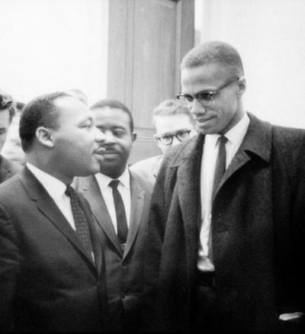

February 25th-27th, 2022

Anacostia Arts Center
1231 Good Hope Road, SE Washington, DC 20020

Come out and experience young Black excellence at its finest!
Dear Friends of CLT:
Welcome to CLT's 2021/22 theatre season! We are proud to present two diverse productions that will entertain, provoke, and inspire you. CLT’s produced its first book of poetry, entitled “Life in Colour...Living Past What You See”, Summer 2021. Teens ages 15 – 17, were introduced to social justice movements and its icons, revealing their inner thoughts through poetry to create the most amazing book of poetry written by teens. Next, playwright Jeff Stetson imagines what would have happened if Dr. King and Malcolm X joined forces in the fight for civil rights. In James Baldwin’s play “The Amen Corner”, Sister Margaret Walker Margaret Alexander, a self-anointed storefront preacher, falls victim to the human condition, as she explores what it means to really love a person to the bitter end. We end our season with CLT’s highly acclaimed and highly anticipated 10 Minute Play Festival. Teen playwrights and poets take us on a creative and magical excursion, inviting you to experience life’s realities through their eyes. This is season…you don’t wanna miss! These young people will make cry, laugh, applaud and reflect. For a more interactive adventure, with CLT and Ward 8 youth, volunteer as a judge or support our annual awards ceremony. Contact us to learn about the many ways to get involved and support community theatre for young people.
For more information contact us at: (202) 710-7819.
CHECK US OUT
CLT’s Social Media Handles:

Children’s Legacy Theatre Inc.
@childrenslegacytheatre

Follow us to stay updated on all future projects!

Children’s Legacy

Theater

2021-2022
Theater Season

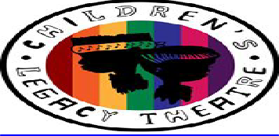
Welcome to
Our Community
Our Stage
Our World

1231 Good Hope Road, SE
Washington, DC 20020
Phone (202) 710-7819
Fax (202) 546-8478
www.childrenslegacytheatre8.org

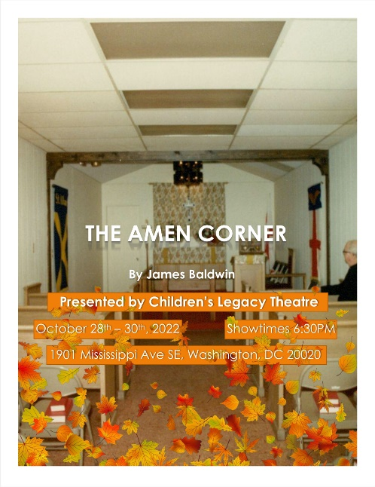
THE AMEN CORNER

By
James Baldwin

Self-anointed Harlem storefront preacher Margaret Alexander is the leader of her flock and about to see her world crumble. Son David her church organist, is set on following in the footsteps of his father, jazz musician Luke. When the errant husband and father comes home to die, Sister Margaret finds herself losing everything but coming to terms with her own true sense of faith.

Anacostia Arts Center
1231 Good Hope Road, SE Washington, DC 20020
October 28th – 30th, 2022 @ 6:30PM

THE MEETING
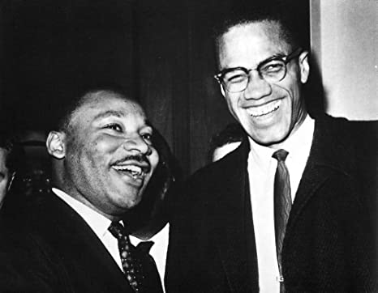

By
Jeff Stetson

The Meeting is a fascinating play that imagines what might have been had a dialogue ever occurred between Malcolm X and Dr. Martin Luther King, Jr.

Solomon G Brown Community Center
2500 Martin Luther King Jr. Ave SE, Washington, DC 20020

December 15th - 17th , 2021 @6:30PM
CLT’s 5th Annual
Ten-Minute Play Festival
FEATURING the Copper Colored Children of Anacostia
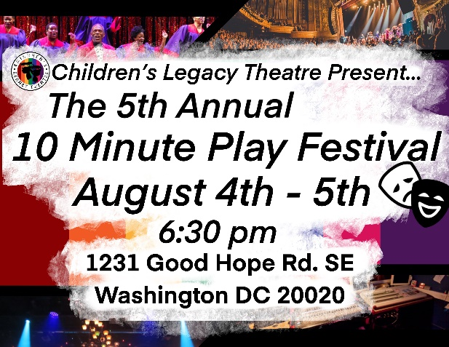
Join us for CLT’s 5th Annual 10 Minute Summer Play Festival. Featuring original plays and choreography, crafted by students, ages 14-17. It is sure will make you laugh, cry, think and feel proud and happy.

Anacostia Arts Center
1231 Good Hope Road, SE Washington, DC 20020

August 4th-5th, 2022 @ 6:30PM

